The Spring Feasts of the Lord
Jesus, the Spotless Lamb of God

Theme: Jesus became the reality of the Passover shadow picture.

Introduction: The children of Israel were in slavery in the land of Egypt for four hundred years. When they began to cry out to the Lord in their anguish, the Lord heard their cries and raised up a deliverer as His instrument to bring judgment upon the gods of the land of the Egyptians.
There were ten plagues in all, each demonstrating that the man made gods of the Egyptians were no match for the true and living God of Abraham, Isaac, and Jacob.
It was upon the pronouncement of the tenth and final plague that God began to unveil to His people a foreshadowing of His great plan for the redemption of all who would believe and receive this incredible gift of God.
Through the Passover sacrifice God put in motion a yearly memorial for His people, which up until this time only Abraham had ever seen a glimpse of. When God commanded him to take his son Isaac, the son of promise to mount Moriah and offer him as a sacrifice there. Abraham obeyed God, and upon arriving at the mountain commanded his servants to wait, while he and Isaac went up the mountain to worship.
Abraham placed the wood for the sacrifice upon the back of his son Isaac and headed up the mountain. Isaac asked his father where the sacrifice was and Abraham speaking prophetically said, “The Lord (will provide a sacrifice.”
When they reached the top of the mountain Abraham built an altar of stone to the Lord, tied his son Isaac with chords and placed him upon the wood. He was about to cut the throat of his son, when the angel of the Lord said, “Abraham, do your son no harm, for now I know you are fully obedient to me, and trust me completely in that you have not even withheld your only son from me.”
The scriptures tell us that this act of faith was credited to Abraham’s account as righteousness. Abraham then looked and saw a Ram caught by the horns in a thicket, which he took and sacrificed in the place of Isaac upon the altar which he had built.
This sacrifice was an incredible shadow picture of the eventual sacrifice of God’s only Son, Jesus, the Messiah. Who would one day willfully lay down His own life as the spotless Lamb of God. Who would shed His blood to take away the sins of the whole world, thus fulfilling the prophetic utterance of Abraham, the father of our faith. “The Lord will provide Himself the sacrifice.”
With the institution of the Passover sacrifice, which Israel was commanded to keep year after year, the Lord put in motion the telling of the story of redemption in such a way that His people would rehears for a year after year, until Yeshua, the Lamb of God would come to fulfill God’s story.

Text: (Leviticus 23:1-8 NKJV) And the LORD spoke to Moses, saying, {2} "Speak to the children of Israel, and say to them: 'The feasts of the LORD, which you shall proclaim to be holy convocations, these are My feasts. {3} 'Six days shall work be done, but the seventh day is a Sabbath of solemn rest, a holy convocation. You shall do no work on it; it is the Sabbath of the LORD in all your dwellings. {4} 'These are the feasts of the LORD, holy convocations which you shall proclaim at their appointed times. {5} 'On the fourteenth day of the first month at twilight is the Lord's Passover. {6} 'And on the fifteenth day of the same month is the Feast of Unleavened Bread to the LORD; seven days you must eat unleavened bread. {7} 'On the first day you shall have a holy convocation; you shall do no customary work on it. {8} 'But you shall offer an offering made by fire to the LORD for seven days. The seventh day shall be a holy convocation; you shall do no customary work on it.'"

I. Jesus, the Spotless Lamb of God
A. Each year that Israel had kept the Passover they anticipated the arrival of the Messiah, their deliverer. Little did they know that Yeshua (Jesus) was about to fulfill their expectations.
B. The Feast of Passover & Unleavened Bread.
1. On the first day of the 10th month of Aviv (Israel’s first month), which occurred during what the Gregorian calendar calls March/April the High Priest would leave the temple to travel to the town of Bethlehem to select the lamb, which would be the Passover Lamb for the nation of Israel.

2. Each family was also to choose a lamb or a goat without spot or blemish to be set aside for Passover as well.

3. Once the Passover Lamb was selected, it was to be kept for four days and inspected. Then if it was found to be without spot, or blemish it was killed and eaten on the evening of the 14th day of the month at sundown.

4. When the sun set on the fourteenth day this marked the beginning of the High Sabbath. This also marked the beginning of the Feast of Unleavened Bread. During this time the children of Israel were to remove all leaven from their homes and to eat bread without leavening.

5. The Jewish day began at sunset no matter where you were. The setting of the sun at twilight on the 14th day of Aviv marked a High Sabbath, a Holy Convocation (Rehearsal) to the Lord. This was the Lord’s Passover. In this the Children of Israel recalled the grace of God when He delivered them from bondage in Egypt. They rejoiced in His grace in the day in which they lived, and they looked forward to the day when Messiah would come, and turn their sorrow into gladness, and give them joy unspeakable and full of glory.

6. Each family was to kill and eat the lamb as the sunset on the evening of the 14th day of Aviv. They were to eat it with bitter herbs and unleavened bread. This has come to be called a Seder meal (or a specified order of events).

7. The Lord commanded that the males of every household were to travel to Jerusalem three times a year to worship before the Lord, during the feasts of Passover, Pentecost, and Tabernacles as holy observances. Passover is one of those times, in which thousands of Jews and their families have for century’s made pilgrimages to Jerusalem to celebrate the Lord’s Passover.

8. At the setting of the sun on the evening of the Passover began a High Sabbath. This was different than the weekly Sabbath. No one was to do any work on the high Sabbath, as this was to be a holy observance, and day of worship to the Lord.

9. Seven days latter on the 21st of the month is another High Sabbath, commemorating God leading His people across the Red Sea, with Moses.

10. During the Feast of Unleavened Bread there will be a weekly Sabbath. On the day after the weekly Sabbath is the Day of First Fruits, which commemorates the first of the harvest of the Barley.

B. Selecting the Passover Lamb
1. On the 10th day of the month of Aviv the High Priest leaves the temple mount to travel to Bethlehem where the Passover Lambs are raised. He is going to select a perfect lamb, without spot or blemish, to kill as the Passover Lamb for the nation of Israel.

2. Each year when the high priest would return from Bethlehem leading the perfect Passover Lamb, the people and priests would line the road waving their palm, evergreen, and cedar bows in celebration of the coming Messiah who would one day come. There were hundreds of thousands of Israelites in Jerusalem at this time, all there to celebrate the Passover with their families filling every home in the city.

3. Once these pilgrims arrived in Jerusalem, they would go to the south wall of the temple and purify themselves in the micvah, or baptism pools in expectation that Messiah may indeed come this year!

II. Behold the Lamb of God
A. Jesus, fulfills the Feast of Passover
(John 1:29-36 NKJV) The next day John saw Jesus coming toward him, and said, "Behold! The Lamb of God who takes away the sin of the world!
1. Jesus, the anointed Lamb of God enters Jerusalem, as the Passover Lamb
(John 12:1-16 NKJV) Then, six days before the Passover, Jesus came to Bethany, where Lazarus was who had been dead, whom He had raised from the dead. {2} There they made Him a supper; and Martha served, but Lazarus was one of those who sat at the table with Him. {3} Then Mary took a pound of very costly oil of spikenard, anointed the feet of Jesus, and wiped His feet with her hair. And the house was filled with the fragrance of the oil. {4} Then one of His disciples, Judas Iscariot, Simon's son, who would betray Him, said, {5} "Why was this fragrant oil not sold for three hundred denarii and given to the poor?" {6} This he said, not that he cared for the poor, but because he was a thief, and had the money box; and he used to take what was put in it. {7} But Jesus said, "Let her alone; she has kept this for the day of My burial. {8} "For the poor you have with you always, but Me you do not have always." {9} Now a great many of the Jews knew that He was there; and they came, not for Jesus' sake only, but that they might also see Lazarus, whom He had raised from the dead. {10} But the chief priests plotted to put Lazarus to death also, {11} because on account of him many of the Jews went away and believed in Jesus. {12} The next day a great multitude that had come to the feast, when they heard that Jesus was coming to Jerusalem, {13} took branches of palm trees and went out to meet Him, and cried out: "Hosanna! 'Blessed is He who comes in the name of the LORD!' The King of Israel!" {14} Then Jesus, when He had found a young donkey, sat on it; as it is written: {15} "Fear not, daughter of Zion; Behold, your King is coming, Sitting on a donkey's colt." {16} His disciples did not understand these things at first; but when Jesus was glorified, then they remembered that these things were written about Him and that they had done these things to Him.

2. Just before the high priest returned from Bethlehem with the Passover Lamb, the true Lamb of God, Yeshua of Nazareth entered the city from the same northern gate riding on a donkey. At that moment His disciples (which numbered in the thousands), began to cry out Hosanna, blessed is He who comes in the name of the Lord.”

3. Upon hearing this, the Levite priests begin to join in, thinking it is the high priest returning from Bethlehem. When the multitudes hear this they rush from their homes, grabbing their greenery and join the chorus, praising Yeshua, the Lamb of God.
(Luke 19:39-40 NKJV) And some of the Pharisees called to Him from the crowd, "Teacher, rebuke Your disciples." {40} But He answered and said to them, "I tell you that if these should keep silent, the stones would immediately cry out."

2. Jesus, His last meal with His disciples, but Not a Passover Meal (Matthew 26:17-30 NKJV) Now on the first day of the Feast of the Unleavened Bread the disciples came to Jesus, saying to Him, "Where do You want us to prepare for You to eat the Passover?"

This was not on the evening of Passover when Jesus ate with His disciples. (John 13:1-5 NKJV) Now before the feast of the Passover, when Jesus knew that His hour had come that He should depart from this world to the Father, having loved His own who were in the world, He loved them to the end. {2} And supper being ended, the devil having already put it into the heart of Judas Iscariot, Simon's son, to betray Him, {3} Jesus, knowing that the Father had given all things into His hands, and that He had come from God and was going to God, {4} rose from supper and laid aside His garments, took a towel and girded Himself. {5} After that, He poured water into a basin and began to wash the disciples' feet, and to wipe them with the towel with which He was girded.

He would not have sent Judas out to by preparations, (as some disciples thought).

If this were the Passover it would be a high Sabbath, and washing of His disciples feet would be working on the Sabbath, which would be forbidden.

After supper they departed and went to the Mount of Olives. Travel was also forbidden on a High Sabbath. This was not the Passover, but rather a prelude to the Passover.

4. Jesus blesses His disciples, and declares that He is the bread of Life, and that the cup of blessing represents the new covenant in His blood. Jesus sends Judas out, because He must remove the leaven.
(1 Corinthians 5:7-8 KJV) Purge out therefore the old leaven, that ye may be a new lump, as ye are unleavened. For even Christ our Passover is sacrificed for us: {8} Therefore let us keep the feast, not with old leaven, neither with the leaven of malice and wickedness; but with the unleavened bread of sincerity and truth.

5. Latter that night Jesus is arrested in the Garden.

III. The Lamb is Inspected for Sacrifice
A. Jesus, God’s Lamb was inspected seven times and found to be without blemish.
1. Pilate - John 8:38 ...I find in Him no fault at all.
2. Herod - Luke 23:22...Why, what evil hath He done? I have found no cause of death in Him...
3. Annas - John 18:23-24 Jesus answered him, If I have spoken evil, bear witness of the evil: but if well, why smittest thou me? Now Annas had sent Him bound unto Caiaphas the high priest.
4. Caiaphas - John 18:14 Now Caiaphas was he, which gave counsel to the Jews, that it was expedient that one man should die for the people.
5. Judas - Matt 27:3-4 Then Judas, which had betrayed him, when he saw that He was condemned, repented himself, and brought again the thirty pieces of silver to the high priests and elders, Saying, I have sinned in that I have betrayed the innocent blood...
6. The Thief on the cross - Luke 23:41...for we receive the due reward of our deeds: but this man hath done nothing amiss.
7. The Centurion - Matt 27:54 Now when the centurion, and they that were with him watching Jesus, saw the earth quake, and those things that were done, they feared greatly saying, Truly this was the Son of God. Or...truly this was a righteous man.

B. The trial and crucifixion of Yeshua (Jesus).
1. After Jesus is arrested in the Garden of Gethsemane, He is taken to the home of Anas, (father-in-law of the high priest Ciaphas).
2. From there He is taken to Ciaphas where they conduct a mock trial.
3. After Ciaphas, He is taken to Pilot’s judgment hall. The religious leaders would not go into Pilot’s judgment hall so that they would not
become defiled, so they would be able to eat the Passover. Thus we see that Jesus could not have possibly eaten the Passover already.
4. Pilot realizes Jesus is an innocent man and tries to find a way to get Him out of this judgment.
(John 19:1-18 NKJV) So then Pilate took Jesus and scourged Him. {2} And the soldiers twisted a crown of thorns and put it on His head, and they put on Him a purple robe. {3} Then they said, "Hail, King of the Jews!" And they struck Him with their hands. {4} Pilate then went out again, and said to them, "Behold, I am bringing Him out to you, that you may know that I find no fault in Him." {5} Then Jesus came out, wearing the crown of thorns and the purple robe. And Pilate said to them, "Behold the Man!"

- These were the very words that the high priest would say on the pronouncement of Passover Lamb being declared spotless.

{6} Therefore, when the chief priests and officers saw Him, they cried out, saying, "Crucify Him, crucify Him!" Pilate said to them, "You take Him and crucify Him, for I find no fault in Him." {7} The Jews answered him, "We have a law, and according to our law He ought to die, because He made Himself the Son of God." {8} Therefore, when Pilate heard that saying, he was the more afraid, {9} and went again into the Praetorium, and said to Jesus, "Where are You from?" But Jesus gave him no answer. {10} Then Pilate said to Him, "Are You not speaking to me? Do You not know that I have power to crucify You, and power to release You?" {11} Jesus answered, "You could have no power at all against Me unless it had been given you from above. Therefore the one who delivered Me to you has the greater sin."

- Jesus tells pilot that this is God’s doing, not man’s. God is providing Himself a sacrifice, just as Abraham had prophesied.
{12} From then on Pilate sought to release Him, but the Jews cried out, saying, "If you let this Man go, you are not Caesar's friend. Whoever makes himself a king speaks against Caesar." {13} When Pilate therefore heard that saying, he brought Jesus out and sat down in the judgment seat in a place that is called The Pavement, but in Hebrew, Gabbatha. {14} Now it was the Preparation Day of the Passover, and about the sixth hour. And he said to the Jews, "Behold your King!" {15} But they cried out, "Away with Him, away with Him! Crucify Him!" Pilate said to them, "Shall I crucify your King?" The chief priests answered, "We have no king but Caesar!" {16} Then he delivered Him to them to be crucified. So they took Jesus and led Him away. {17} And He, bearing His cross, went out to a place called the Place of a Skull, which is called in Hebrew, Golgotha, {18} where they crucified Him, and two others with Him, one on either side, and Jesus in the center.

When pilot pronounced judgment upon Jesus, he then placed the wood of the sacrifice upon His back, just as Abraham had done with his son Isaac.

God built his own altar out of stone called ‘The Temple.’

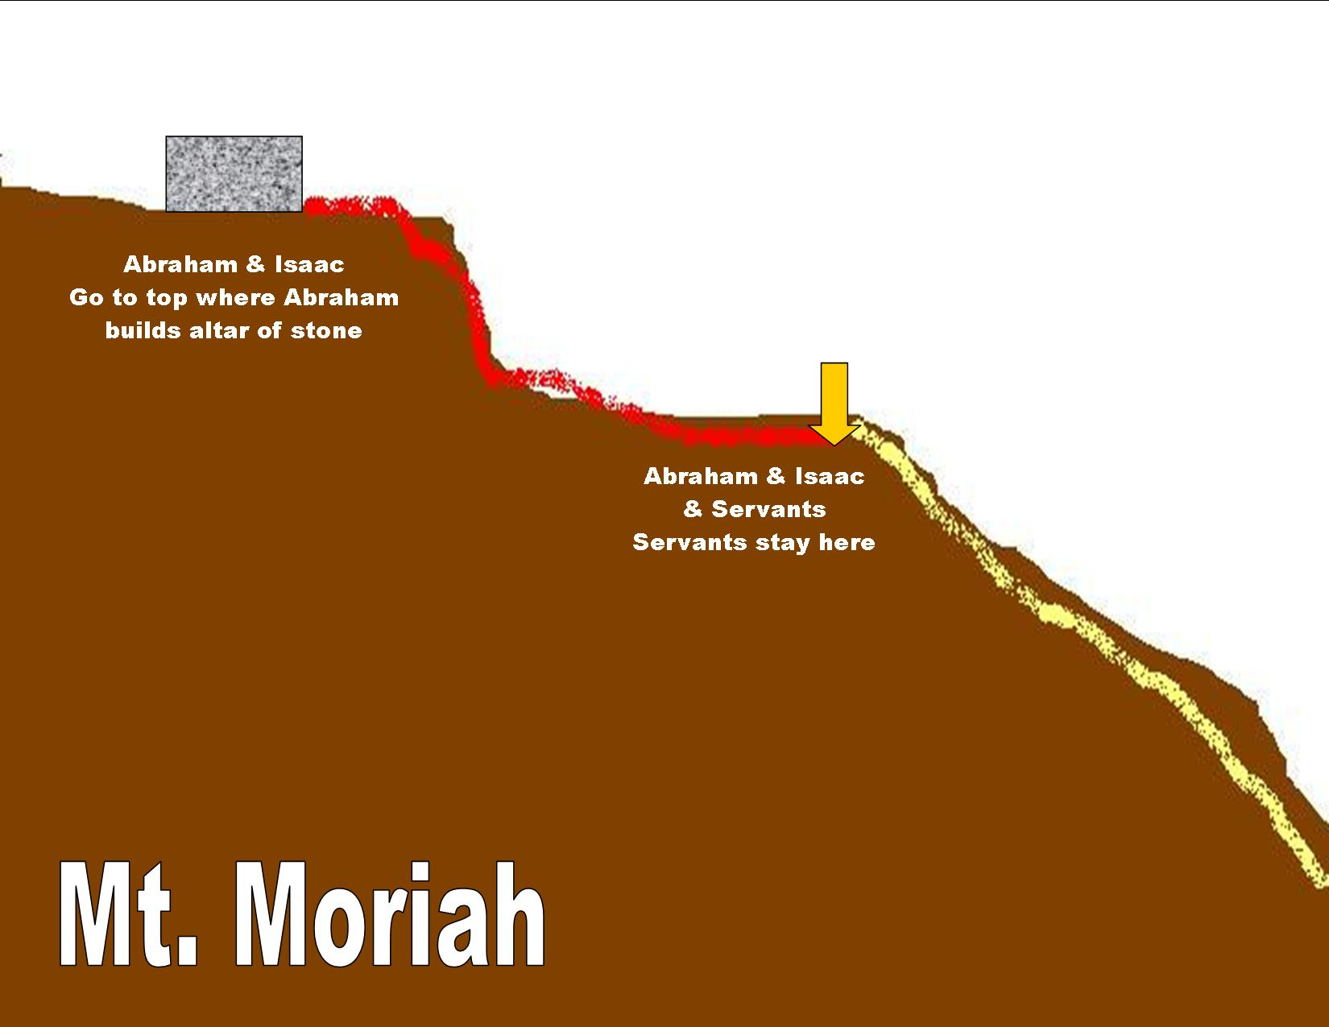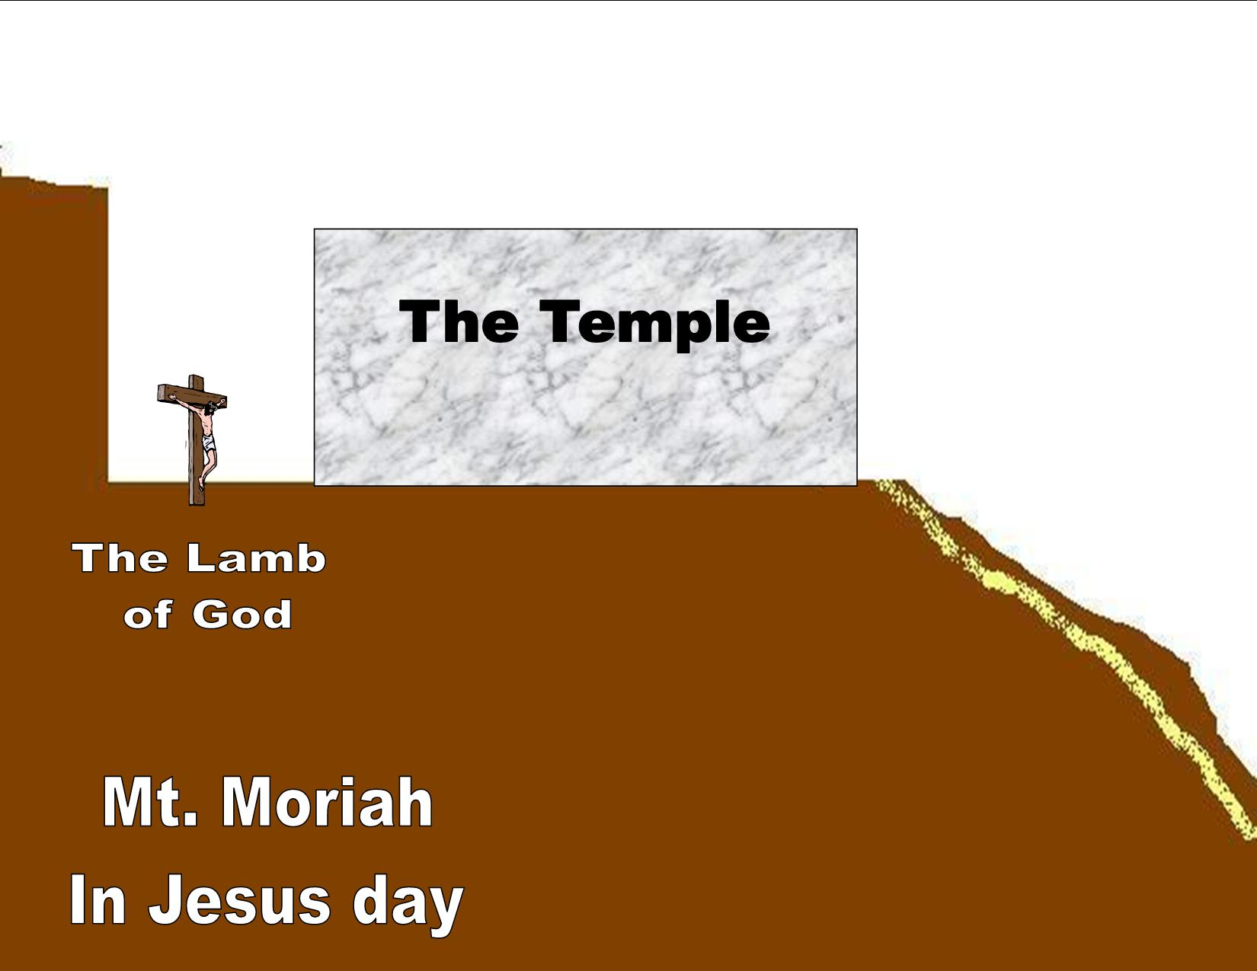

Jesus was led out to be crucified in the same place that Abraham placed Isaac on the altar. The only difference, is that this was the fulfillment of what God foretold through Abraham.

- At the same time Jesus was being crucified, thousands of Lambs were being slaughtered on the Temple Mount.

- When the high priest was about to sacrifice the final lamb, the spotless Passover Lamb, he would stop and say “I thirst.” Then take a sip of water and proceed to kill the Passover Lamb. Then he would cry “It is finished.”
(John 19:28-30 NKJV) After this, Jesus, knowing that all things were now accomplished, that the Scripture might be fulfilled, said, "I thirst!" {29} Now a vessel full of sour wine was sitting there; and they filled a sponge with sour wine, put it on hyssop, and put it to His mouth. {30} So when Jesus had received the sour wine, He said, "It is finished!" And bowing His head, He gave up His spirit.
(Matthew 27:50-54 NKJV) And Jesus cried out again with a loud voice, and yielded up His spirit. {51} Then, behold, the veil of the temple was torn in two from top to bottom; and the earth quaked, and the rocks were split, {52} and the graves were opened; and many bodies of the saints who had fallen asleep were raised; {53} and coming out of the graves after His resurrection, they went into the holy city and appeared to many. {54} So when the centurion and those with him, who were guarding Jesus, saw the earthquake and the things that had happened, they feared greatly, saying, "Truly this was the Son of God!"

Because the Sun was about to set the High Sabbath was about to begin, so the priests asked that the legs of the victims be broken so they would die quickly. When they came to break Jesus legs they found He had already died. Jesus was put to death on the evening of the 14th day.
(Mark 15:33 NKJV) Now when the sixth hour had come, there was darkness over the whole land until the ninth hour. Sixth hour - 12:00 noon. Ninth hour - 3:00 p.m.

As they were removing Jesus body from the cross to be placed in the tomb for burial, is the same time all the lambs that had been slaughtered for Passover were being taken off of the temple mount to be placed in ovens to be roasted with fire.

IV. The Chronology of Christ's Crucifixion and Resurrection

Saturday 10th of Aviv - Passover Lamb chosen and set aside, Jesus enters Jerusalem John 12:1-16
Sunday 11th
Monday 12th
Tuesday 13th - Lamb kept for four days. Jesus eats Passover Seder with His disciples. Latter He is arrested.

Wednesday 14th - Passover/Christ crucified. Jesus Crucified/Day of Preparation. He is placed in tomb before sunsets. Luke 23:54; Mark 15:42, John 19:31

Thursday 15th - Feast of Unleavened Bread, 3 Nights & 3 Days Matthew 12:40
High Sabbath or High Day Luke 23:54; Matthew 27:62; John 19:31

Friday 16th - Secular day/Spices prepared by Women Luke 23:55-56

Saturday 17th - Weekly Sabbath/4th Commandment Luke 23:54; Matthew 28:1; Exodus 20:8-11

Sunday 18th - First day of week, the morrow after the Sabbath, Jesus resurrected
Sabbath, Resurrection of Jesus, Day of Sheaf of First fruits waving of first ripe grain.
Matthew 28:1; Mark 16:1-6; John 201:1; Luke 24:1

Conclusion: Jesus died on Passover rather than the Day of Atonement because Passover is a picture of personal salvation.

